Scopes of the Applications to be integrated:
Okta
Okta is an enterprise-grade, identity management service, built for the cloud, but compatible with many on-premises applications.

Zluri + Okta
Integrate Okta with Zluri to discover all the apps your employees use, app usage and detailed security overview of each application. You can also add users to Okta and automate onboarding/offboarding processes. Zluri’s integration with Okta includes the following capabilities.

Integrate Okta with Zluri to discover shadow IT
Enable Okta data to flow into Zluri to discover shadow IT, and unlock powerful reporting and workflow automation. Use Okta data to trigger custom workflows and alerts - no code required. Integrations automatically merges Okta data to the Zluri employee record, so you can run new reports that combine any data within Zluri with Okta data.

Get detailed security analysis of each application
Integrating Okta with Zluri gives you detailed security analysis of each application signed in through Okta. It highlights the applications having risk sensitive scope access and gives you an overall threat perception of your application ecosystem.

Onboard & offboard employees with a single click
You can realise the full potential of our workflows by seamlessly adding users to Okta, removing users, assigning licences etc. just by integrating Zluri with Okta. Automate all such tasks with a single click.

Manage groups
You can assign your employees to groups in Okta, which are created around attributes like project and team. Managing groups in Okta takes your provisioning automation to the next level.

Manage Data Permissions for users
Seamlessly manage the permissions for the users on your domain.

Supported Plans
- Single Sign-on
- Multi-factor Authentication
- Universal Directory
- Lifecycle Management
- API Access Management
- Advanced Server Access
- Access Gateway
- Workflows

Integration Details
- User Created Date
- Last Login
- Sign In Activity
- Activity Log
- User Source status
- Email
- Audit log
- Integration log

Scopes
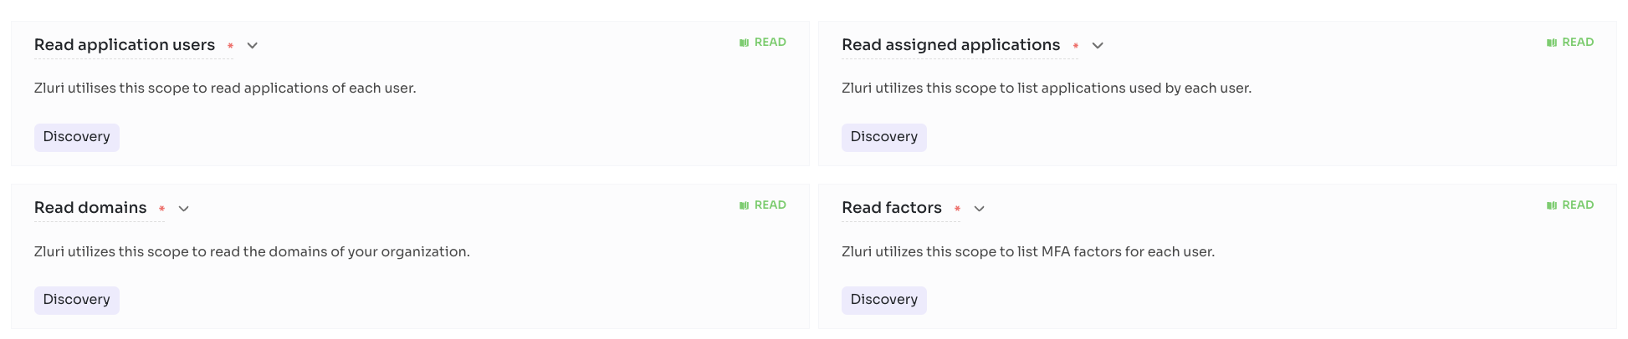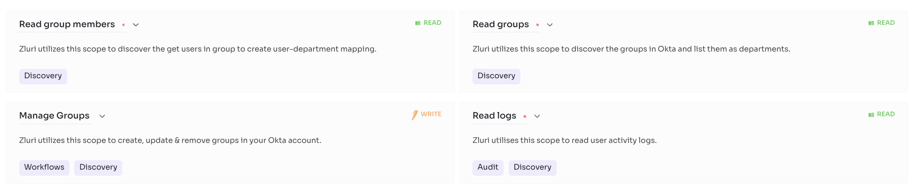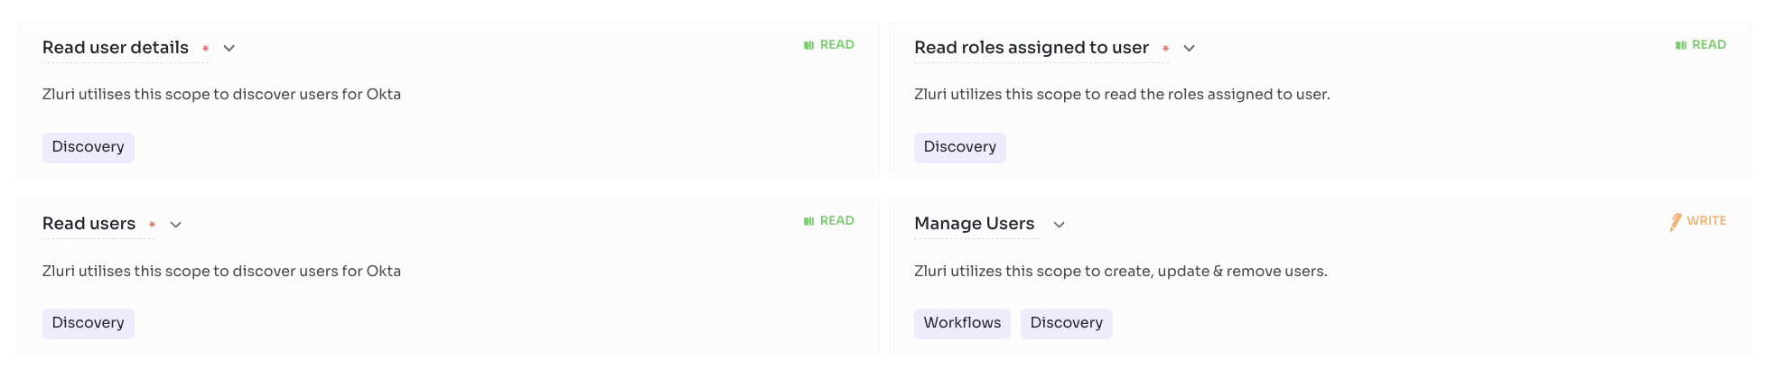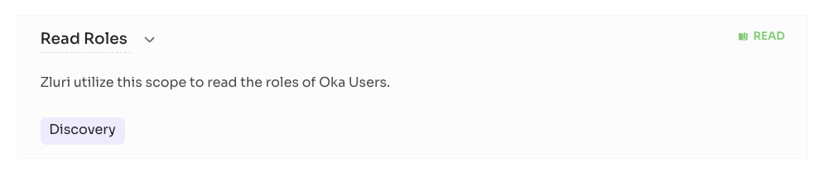
Steps to Connect
Step 0 :

Before you begin integration at Zluri
- Ensure to have the Okta Administrator account.
- Ensure to have the Okta API Credentials (API Token, Domain URL).
Step 1 :

Get API credentials at Okta
How to add an API Key
- Log in to https://okta.com/ with admin credentials.
- Go to Security and select API from the left menu.
- On the API Keys page, click Tokens, provide a name, and click Create Token.
- Copy and securely store the new API key before clicking Finish.
2. Get Okta Organization URL.
- Log in to https://okta.com/ with admin credentials.
- Go to the Top right corner of the Profile and click on it. https://developer.okta.com/docs/guides/find-your-domain/findorg/
- Copy and securely store the Okta Organization URL.
Step 2 :

Begin integration at Zluri
Step 3 :

Review and add scopes
- Review the listed Required Scopes.
- Add additional Other Scopes (optional).
- Proceed further to initiate Self or Co-worker authorization.
Step 4 :

Authorise connection request
Enter the following details
- API Key
- Okta Organization URL

Ironclad (Beta)

From making to managing to storing, Ironclad Digital Contracting streamlines every part of your company's contract process — so you can focus on legal work, not paperwork.

Zluri + Ironclad (Beta)
With direct integration with Ironclad, you can easily track which users use Ironclad & how frequently they use Ironclad and audit their access regularly to meet your security requirements. You can also monitor Ironclad usage & optimise spend. With onboarding & offboarding workflows you can automate the complex process of adding a user to Ironclad or removing a user from Ironclad.
Connect Ironclad to Zluri discover Ironclad users & usage
Integrating Ironclad with Zluri gives you detailed visibility into Ironclad users & usage. You can track which users hold Ironclad licences & how frequently they use Ironclad. You can also identify inactive users to optimise Ironclad licences & spend.
Create and Remove Accounts in Ironclad
Connect Ironclad with Zluri to automatically create and remove user accounts when you onboard and offboard employees. Automate adding users to all required channels through workflows.
Manage Groups in Ironclad
You can automatically assign your users to Groups in Ironclad accounts, which are created around attributes you design.

Integration Details
Email

Scopes
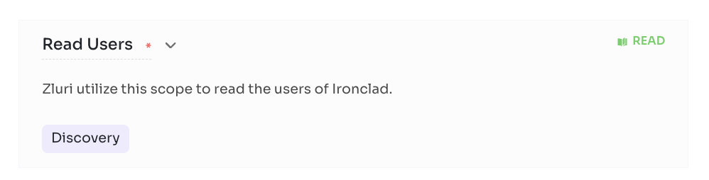

Steps to connect
Step 1 :
Log into your Ironclad account.
Step 2 :
Click on your Profile -> Company Settings -> API -> Access Tokens -> Create an Access Token, copy the API key you just created.
Step 3 :
Paste the copied API key in place of Api Key.

Coupa
Coupa Business Spend Management makes it simple for employees to shop and create purchase requisitions for whatever they need. When your employees have a request, Coupa's software gently guides them towards filling that need in the right way. From bubbling preferred items to the top of search results to taking account of contracted benefits such as preferred pricing and volume discounts, doing the right thing is easy for users.

Zluri + Coupa (Beta)
With direct integration with Coupa, you can easily track which users hold Coupa licences & how frequently they use it. You can also monitor Coupa usage & optimise spend.
Connect Coupa to Zluri and discover Coupa users & usage
Integrating Coupa with Zluri gives you detailed visibility into Coupa users & usage. You can track how frequently they use the application. You can also identify inactive users to optimise Coupa licences & spend.

Integration Details
- Email
- Contracts attachment
- Contract start date
- Contract end date
- Total contract value

Scopes
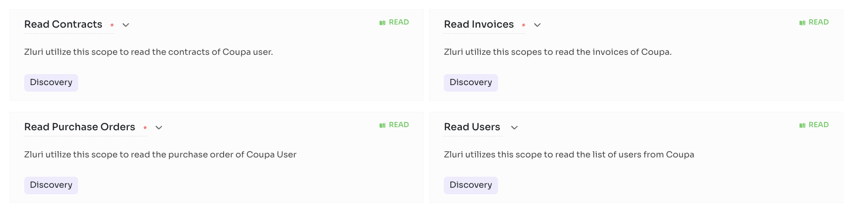

Steps to connect
Step 1 :
Log into your Coupa Account.
Step 2 :
Click on Setup -> Oauth2/OpenID Connect Clients -> Select Client Credentials in the Grant-Type Drop Down -> Fill all the other details asked there -> Select the following scope values core.user.read, core.contract.read, core.invoice.read, core.purchase_order.read -> now save the client.
Step 3 :
Now Identifier is your Client Id and Secret is your Client Secret.
Step 4 :
For URL , use your domain, For example https://zluri.coupahost.com/

Netsuite
NetSuite is one of the market leaders when it comes to providing accounting services. It offers dynamic accounting and financial services to businesses of all sizes from all types of industries, from software companies to transport & logistics companies. This software offers almost all the possible services related to accounting to ensure smooth and better working of the organisation. The ‘SuiteAnswers’ feature provided by the software helps any business organisation to resolve their queries related to the services as well as increase their knowledge related to the industry.

Zluri + NetSuite (Rest)
With direct integration with Netsuite, Zluri fetches the list of expenses from Netsuite and automatically maps them to the SaaS apps. This gives you automated and real time visibility into your SaaS spends.
User Wise Spends
You also get user wise & department wise spends for every single SaaS application.

Departmental Spend & Budget Insights
Get all information regarding your organisation's SaaS budget & spends at a single place. And also populate renewal calendar, Zluri recognizes the recurring spend patterns to populate all SaaS renewals in a calendar view to never miss an upcoming renewal

View list of expenses, vendors, employees
View list of all expenses, vendors, employees from your organisation on Netsuite

Supported Plans
- Subscription based

Integration Details
- User Created Date
- User Source status
- Role
- Email
- Transactions

Scopes
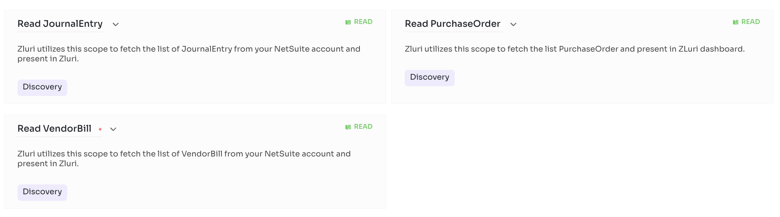

Steps to connect
Detailed steps: https://support.zluri.com/support/solutions/articles/73000606947-netsuite-rest-integration

Zip
At Zip, our mission is to simplify the procurement process for your organisation, and that starts with ensuring the security and privacy of your data. To honour our commitment, we want to empower you to know how your data is used and protected throughout its entire lifecycle.

Zluri + Zip Hq
With direct integration with Zip Hq, Zluri fetches the list of expenses from Zip Hq and automatically maps them to the SaaS apps. This gives you automated and real time visibility into your SaaS spends.
Track all your SaaS expenses at a single place
Integrating with Zip Hq helps you find all your SaaS spends in the Zluri dashboard.

User Wise Spends
You also get user wise & department wise spends for every single SaaS application.

Departmental Spend & Budget Insights
Get all information regarding your organisation's SaaS budget & spends at a single place.

Populate renewal calendar:
Recognize the recurring spend patterns to populate all SaaS renewals in a calendar view to never miss an upcoming renewal.

Add and remove user in Zip Hq:
Connect Zip Hq with Zluri to automatically add and remove users in Zip Hq while onboarding and offboarding. Automate the process through onboarding and offboarding workflows.

Integration Details
- Email

Scopes
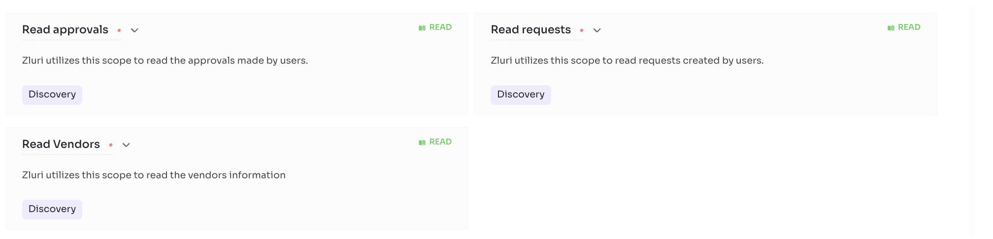

Steps to connect
Step 1 :
Login to Zip Hq website and create the required api key.
Step 2 :
Use the created api key in Zluri Portal to connect with Zip Hq

Asana

Asana is an online team collaboration and workflow management tool.

Zluri + Asana
With direct integration with Asana, you can easily track which users hold Asana licences & how frequently they use Asana. You can also monitor Asana usage & optimise spend. With onboarding & offboarding workflows you can automate the complex process of adding a user to Asana or removing a user from Asana.
Connect Asana to Zluri discover Asana users & usage
Integrating Asana with Zluri gives you detailed visibility into Asana users & usage. You can track which users hold Asana licences & how frequently they use Asana. You can also identify inactive users to optimise Asana licences & spend.

Create and Remove User Accounts in Asana
Connect Asana with Zluri to automatically create and remove user accounts when you onboard and offboard employees. Automate adding users to all required channels through workflows.

Manage Teams, Projects & Tasks in Asana
You can automatically assign your employees to Teams, Projects & Tasks in Asana, which are created around attributes you design.

Supported Plans
Basic
Premium
Business

Integration Details
- Email

Scopes
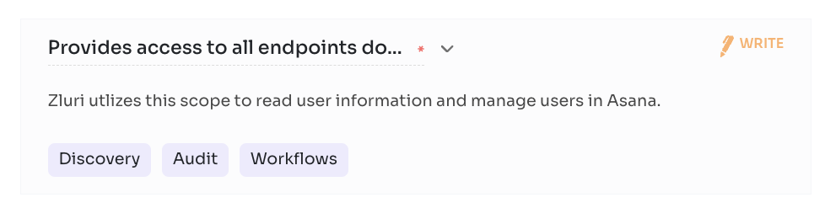

Steps to connect

Step 0 :

Before you begin integration at Zluri
- Ensure to have an Asana account.
Step 1 :
Log in to https://asana.com/ with your credentials.
Step 2 :

Begin integration at Zluri
- Begin Connect Integration or Connect another instance.
Step 3 :

Review and add scopes
- Review the listed Required Scopes.
- Add additional Other Scopes (optional).
- Proceed further to initiate Self or Co-worker authorization.
Step 4 :

Authorise connection request

Atlassian

Configures and administers Jira Software, Jira Core and/or Jira Service Desk, and related products such as apps. Manages global settings including users and groups, roles, global permissions, and schemes.

Zluri + Atlassian Admin
With direct integration with Atlassian Admin , you can easily track which users use Atlassian Admin & how frequently they use Atlassian Admin and audit their access regularly to meet your security requirements. You can also monitor Atlassian Admin usage & optimise spend. With onboarding & offboarding workflows you can automate the complex process of adding a user to Atlassian Admin or removing a user from Atlassian Admin .
Connect Atlassian Admin to Zluri discover Atlassian Admin users & usage
Integrating Atlassian Admin with Zluri gives you detailed visibility into Atlassian Admin users & usage. You can track which users hold Atlassian Admin licences & how frequently they use Atlassian Admin . You can also identify inactive users to optimise Atlassian Admin licences & spend.

Manage Roles in Atlassian Admin
You can automatically assign your employees to groups in Atlassian Admin , which are created around attributes you design. Configure your groups using specific employee names, or by fields in Zluri such as department, role, employment status, or management level.
Create and Remove Accounts in Atlassian Admin
Connect Atlassian Admin with Zluri to automatically create and remove user accounts when you onboard and offboard employees. Automate adding users to all required channels through workflows.

Manage Groups in Atlassian Admin
You can automatically assign your users to Groups in Atlassian Admin accounts, which are created around attributes you design. Configure your groups using specific employee names, or by fields in Zluri such as department, role, employment status, or management level.

Get Supplier Information:
Access the supplier information for your organisations seamlessly through Zluri.

Supported Plans
- Project Management Software
- IT Service Management Software
- Code Hosting Software
- File Sharing Software

Integration Details
- User Profile Image
- Last Login
- User Source status
- Role
- Email
- Licence Info

Scopes
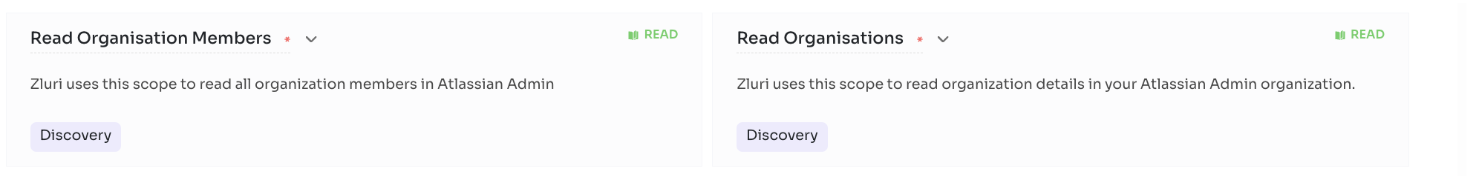

Steps to connect

Step 0 :

Before you begin integration at Zluri
- Ensure to have the Atlassian AdminAdministrator account.
- Ensure to have the Atlassian Admin API Credentials (API Key).
- Verify your domain on Atlassian Admin[Help : Verify Domain]

Step 1 :

Get API credentials at Atlassian Admin
- Log in to your Atlassian admin https://admin.atlassian.com/ and sign in to your Atlassian account with administrator privileges.
- Once logged in, select Settings followed by API keys.
- Click the Create API key button in the top right corner.
- Enter a descriptive name for your API key (to help you identify its purpose) and set the expiry date (optional). Then, click Create.
- Copy both the Organization ID and the API key.
2. Generate SCIM API Key.
- Log in to Atlassian Admin and select your Organisation name
- Click on Security in the header
- On the left sidebar, click Identity Providers.
- Choose an existing or connect to a new directory by using the API Key and the URL for the directory.
Step 2 :

Begin integration at Zluri
- Begin Connect Integration or Connect another instance.
Step 3 :

Review and add scopes
- Review the listed Required Scopes.
- Add additional Other Scopes (optional).
- Proceed further to initiate Self or Co-worker authorization.
Step 4 :

Authorise connection request
Enter the following details
- API Key,SCIM API Key [Optional],SCIM Base URL [Optional]

GitHub

GitHub, Inc. is a provider of Internet hosting for software development and version control using Git. It offers the distributed version control and source code management functionality of Git, plus its own features.

Zluri + GitHub
With direct integration with Github, you can easily track which users hold Github licences & how frequently they use Github. You can also monitor Github usage & optimise spend. With onboarding & offboarding workflows you can automate the complex process of adding a user to Github or removing a user from Github.
Connect Github to Zluri discover Github users & usage
Integrating Github with Zluri gives you detailed visibility into Github users & usage. You can track which users hold Github licences & how frequently they use Github. You can also identify inactive users to optimise Github licences & spend.
Create and Remove User Accounts (Members) in Github
Connect Github with Zluri to automatically create and remove user accounts when you onboard and offboard employees. Automate adding users to all required channels through workflows.

Manage Repositories, Teams & Roles in Github
You can automatically assign your members to repositories and teams with specified roles in Github account, which are created around attributes you design.

Supported Plans
- Free
- Team
- Enterprise

Integration Details
- User Profile Image
- Email

Scopes
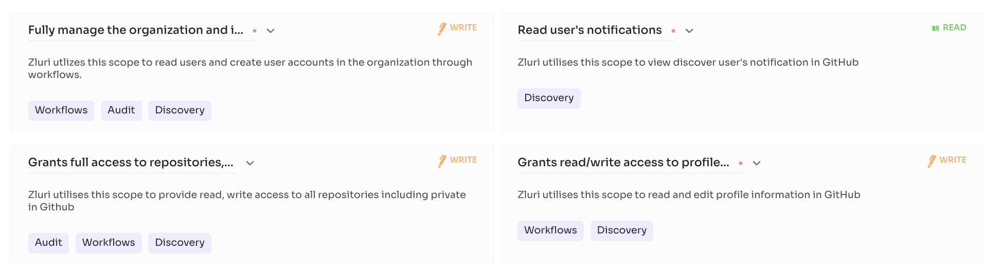

Steps to connect

Step 0 :

Before you begin integration at Zluri
- Ensure to have a Github account.
Step 1 :
Log in to https://github.com/login with your credentials.
Step 2 :

Begin integration at Zluri
- Begin Connect Integration or Connect another instance.
Step 3 :

Review and add scopes
- Review the listed Required Scopes.
- Add additional Other Scopes (optional).
- Proceed further to initiate Self or Co-worker authorization.
Step 4 :

Authorise connection request

IntelliJ = Jetbrains HUB + Jetbrains

Jetbrains HUB
JetBrains Hub enables advanced integration between JetBrains team collaboration tools. For example, when you use Hub to connect your Upsource and YouTrack installations, you can create new issues directly from your code reviews.

Integration Details
- User Profile Image
- Two-Factor authentication
- Activity Log
- Role
- Email
- Licence Info

Scopes
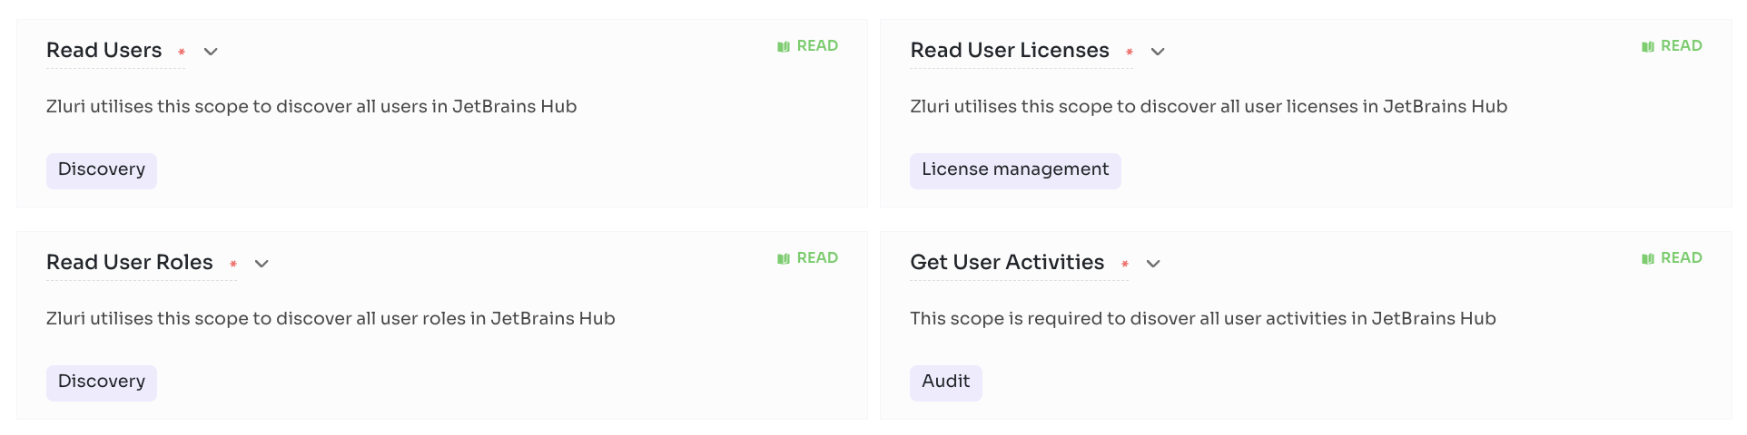

Steps to connect

Step 1 :JetBrains connection takes multiple steps to connect. Please follow this link to connect.
Step 2 :Login into JetBrains Account.
Step 3 :For token, navigate to Settings -> Users
Select a user ->Account Security and click on Generate a New token and paste the token.
Step 4 : To get the connect URL, please login to your Jetbrains account and copy the URL.

JetBrains

JetBrains is a cutting-edge software vendor specialising in the creation of intelligent development tools, including IntelliJ IDEA

Scopes
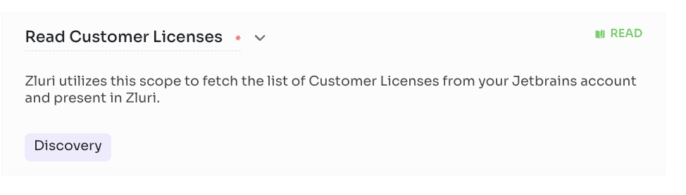
Steps to connect

Step 1 :To access the methods, you need two parameters.
Step 2 :Your customer code for the X-Customer-Code parameter. The customer code is a unique Organisation ID. To find your customer code, go to your JetBrains Account and look for the number next to your organisation's name.
Step 3 :Pass this value to the X-Customer-Code parameter.
Step 4 :Your access token for the X-Api-Key parameter. Go to your JetBrains Account. In the menu on the left, click your organisation's or team's name and then click Administration.
Step 5 :Click Generate Token.
Step 6 :The dialog that pops up will show you the token. For security reasons, you'll only see it once. Save it in a secure location before closing the dialog. Don't share your token with anyone else.
Step 7 :If you lose your token, you'll need to generate a new one. Generating a new token will invalidate the previous one.
Step 8 : For details documentation check this Link

Microsoft Office 365

Microsoft 365 combines collaboration tools, the Office suite of Microsoft Office 365 productivity apps, security & cloud services

Zluri + Microsoft 365
With direct integration with Microsoft 365, you can easily track which users hold Microsoft 365 licences & how frequently they use Microsoft 365. You can also monitor Microsoft 365 usage & optimise spend. With onboarding & offboarding workflows you can automate the complex process of adding a user to Microsoft 365 or removing a user from Microsoft 365.

Connect Microsoft 365 to Zluri discover Microsoft 365 users & usage
Integrating Microsoft 365 with Zluri gives you detailed visibility into Microsoft 365 users & usage. You can track which users hold Microsoft 365 licences & how frequently they use Microsoft 365. You can also identify inactive users to optimise Microsoft 365 licences & spend.

Create and Remove Accounts in Microsoft 365
Connect Microsoft 365 with Zluri to automatically create and remove user accounts when you onboard and offboard employees. Automate adding users to all required channels through workflows.

Manage Roles in Microsoft 365
You can automatically assign your employees to groups in Microsoft 365, which are created around attributes you design. Configure your groups using specific employee names, or by fields in Zluri such as department, role, employment status, or management level.

Keep track of MS 365 licences
Keep track of licences being used by your employees in your MS 365 account.

Supported Plans
- Home
- Business
- Enterprise
- Education

Integration Details
- Last Login
- User Source status
- Email
- License Info

Scopes
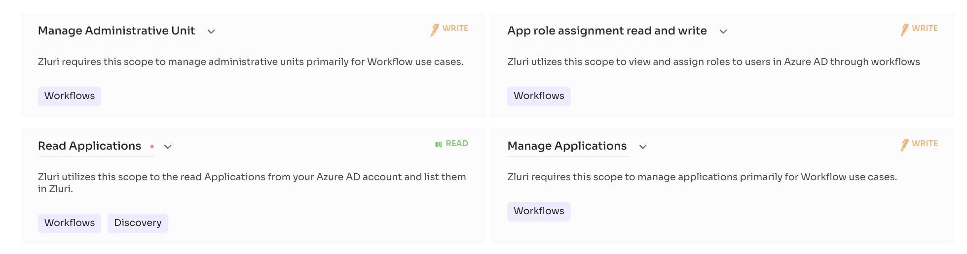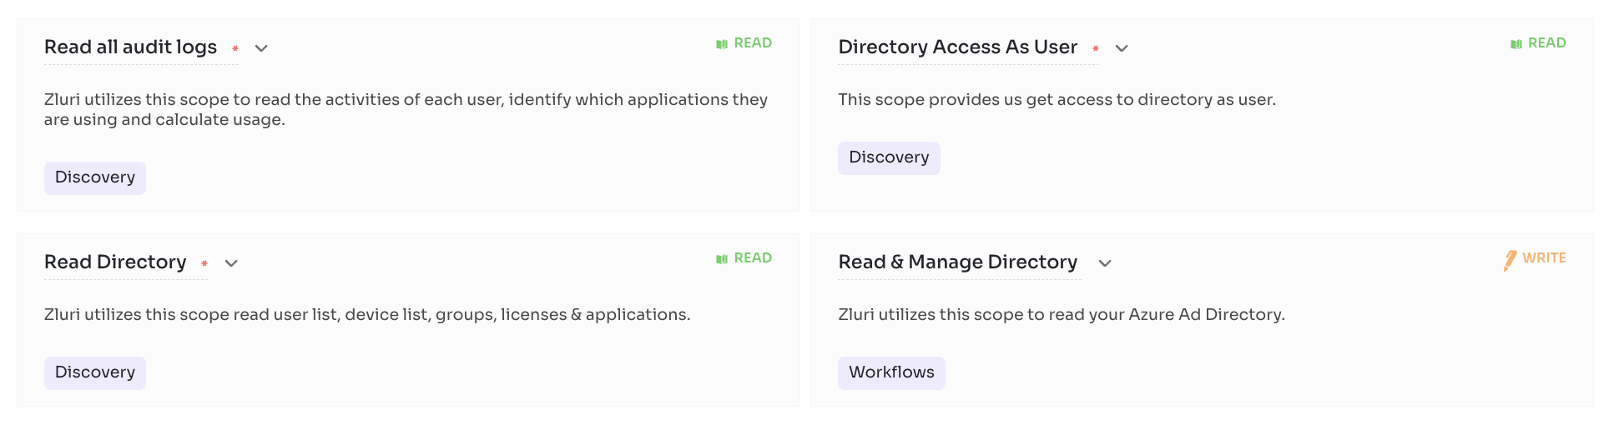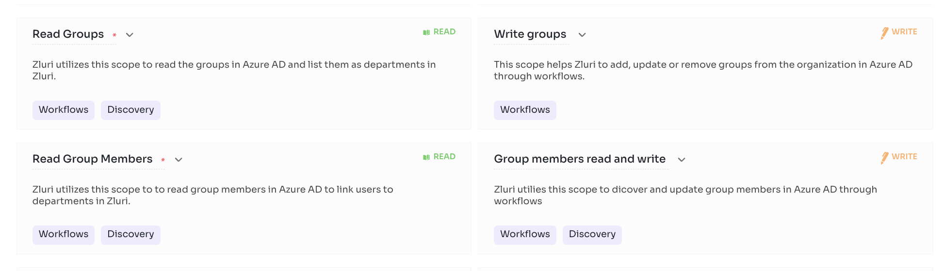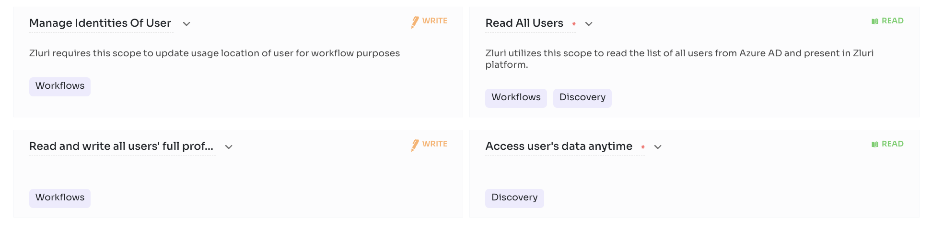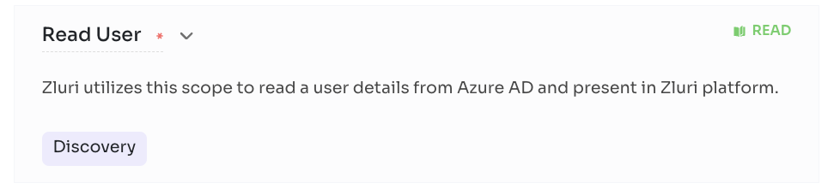

Steps to connect

Step 1 :By default, user details will be hidden for all Microsoft 365 reports. You will need to enable the setting manually in your admin dashboard for Zluri to access it. Please follow the below steps to enable it.
Step 2 : Visit the Admin Center.
Step 3 :Select scopes according to your needs to make the most out of Zluri's Discovery, Workflows, SAML or License Management features. You can also select default scopes for a hassle-free experience.
Step 4 :Integration with Microsoft 365 requires authorization from the Microsoft 365 administrator. If you have the Microsoft 365 credentials you can authorise yourself. Or you can send an invite to your co-worker to complete the authorization. Once connected, Zluri allows you to save this connection instance. You can also connect multiple instances of an integration with additional scopes according to your requirements.

Smartsheet
Smartsheet is the enterprise platform for dynamic work. A leading cloud-based platform for work management, Smartsheet empowers organisations and teams to dynamically plan, execute, and report on work at scale, resulting in more efficient processes, innovative solutions, and better business outcomes. Today over 90% of Fortune 100 companies and over 75% of Fortune 500 companies rely on the secure, scalable Smartsheet platform to connect the entire enterprise. The single Smartsheet platform gives people a solution flexible enough to adapt to the changing needs of dynamic work across a broad array of departments and use cases.

Zluri + Smartsheet
With direct integration with Smartsheet, you can easily track which users hold Smartsheet licences & how frequently they use Smartsheet. You can also monitor Smartsheet usage & optimise spend.

Connect Smartsheet to Zluri discover Smartsheet users & usage
Integrating Smartsheet with Zluri gives you detailed visibility into Smartsheet users & usage. You can track which users hold Smartsheet licences & how frequently they use Smartsheet. You can also identify inactive users to optimise Smartsheet licences & spend.

Manage Roles in Smartsheet
You can automatically assign your employees to groups in Smartsheet, which are created around attributes you design. Configure your groups using specific employee names, or by fields in Zluri such as department, role, employment status, or management level.

Supported Plans
- Pro
- Business
- Enterprise

Integration Details
- User Profile Image
- User Source status
- Role
- Email
- Group

Scopes
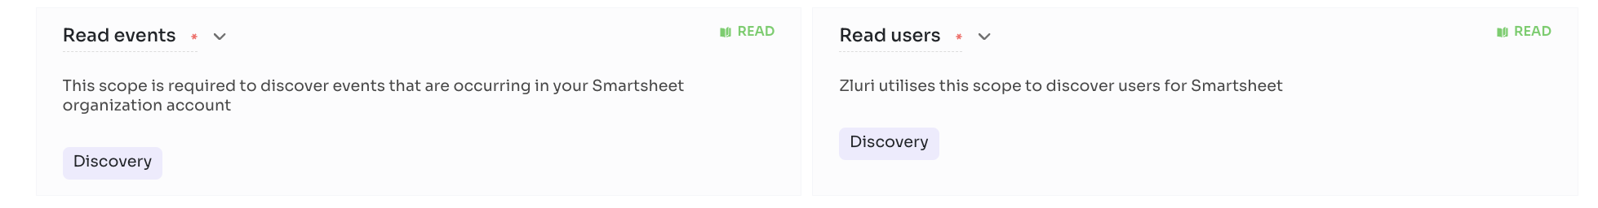

Steps to connect
Step 0 :

Before you begin integration at Zluri
- Ensure to have the Smartsheet Administrator account.
- Ensure to have the Smartsheet API Credentials (API Key).
Step 1 : Get API credentials at Smartsheet
- Log in to https://www.smartsheet.com/ with admin credentials.
- Navigate to Account > Apps & Integrations > API Access
- Enable the API Integration
- .Generate an access token and use the Secret key as a token
- Copy and securely store the new API key
Step 2 : Begin integration at Zluri
Step 3 :

Review and add scopes
- Review the listed Required Scopes.
- Add additional Other Scopes (optional).
- Proceed further to initiate Self or Co-worker authorization.
Step 4 : Authorise connection request
You or your co-worker admin can complete this step based on your previous authorization type. Form-based API
- Enter the appropriate API credentials to connect.
- API Token

Tableau
The Tableau platform provides the breadth and depth of capabilities that enterprises need, and adapts to your environment with unmatched flexibility and choice, while meeting the toughest governance and security requirements. People love using Tableau because it is both powerful and intuitive. Tableau leads the industry with the most passionate user community, over 80,000 customers, and a commitment to customer-focused innovation.

Zluri + Tableau
With direct integration with Tableau, you can easily track which users use Tableau & how frequently they use Tableau. You can also monitor Tableau usage & optimise spend. With onboarding & offboarding workflows you can automate the complex process of adding a user to Tableau or removing a user from Tableau.
Connect Tableau to Zluri discover Tableau users & usage
Integrating Tableau with Zluri gives you detailed visibility into Tableau users & usage. You can track which users use Tableau & how frequently they use Tableau. You can also identify inactive users to optimise Tableau licences & spend.
Create and Remove Accounts in Tableau
Connect Tableau with Zluri to automatically create and remove user accounts when you onboard and offboard employees. Automate adding users to all required channels through workflows.
Manage Groups and Roles in Tableau
You can automatically assign your employees to groups in Tableau with specified roles in Zluri.
Manage User favourites in Tableau
Integrating Tableau with Zluri, You can mark and unmark datasource, projects and workbooks as favourites for a user in Tableau.

Supported Plans
- Subscription based

Integration Details
- Last Login

Scopes
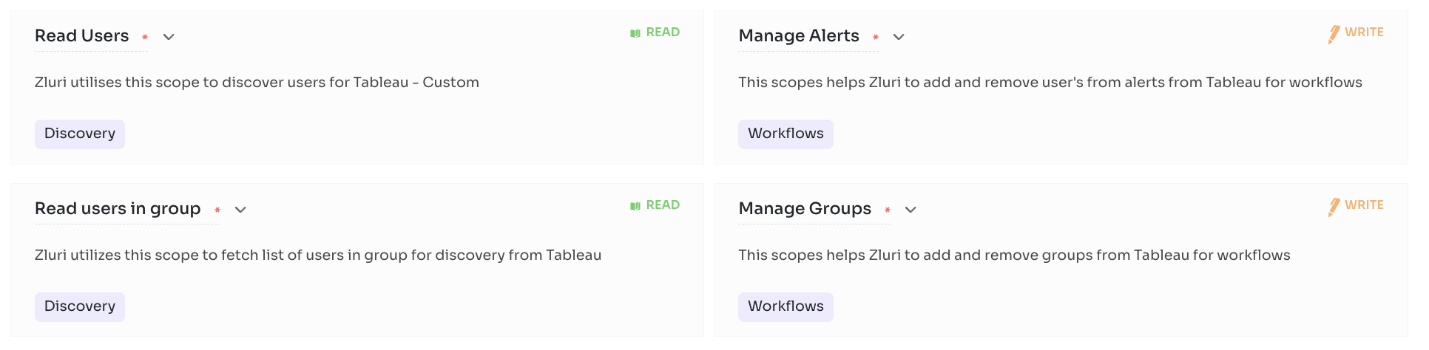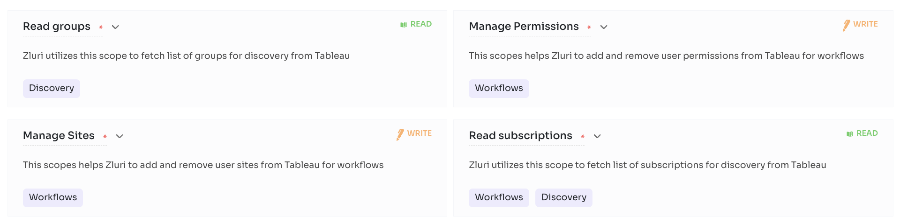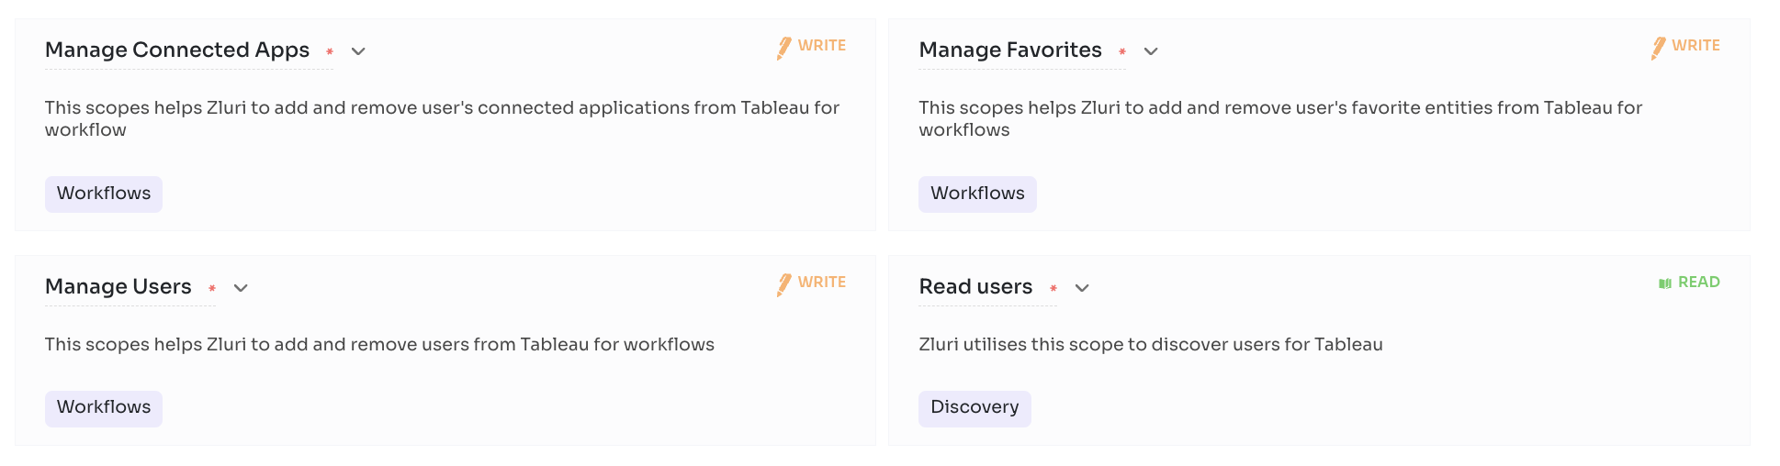

Steps to connect

Step 1 : Base Url is the url for your assembly Dashboard
eg: https://prod-apnortheast-a.online.tableau.com
Copy Base url and Site Name as mentioned in attached screenshot.
NOTE: If you have multiple sites in your account you have to connect separately for each site.
Step 2 : Sign in to Tableau Cloud as a site admin and navigate to the Settings page -> Enable personal access tokens -> Set Expiration Period.

Step 3 : Click on Your Profile -> My Account Settings -> Under Personal Access Tokens, enter a descriptive name for your token in the Token Name field, and then click Create Token. -> Copy Token Name and Secret from there and paste it here.

Zoom
Zoom comes with a range of cloud video conferencing capabilities, including HD voice and video functionality, dual streams for dual screens, the ability to join as a view-only attendee, as well as by Zoom Rooms and telephone dial-in. It also has accessibility features, which allow employees who have disabilities to schedule, attend, and participate in Zoom meetings and webinars. The group collaboration features allow for simultaneous screen sharing, group messaging, whiteboarding, annotation and co-annotation, iOS mirroring on iPhone or iPad, and the ability to share documents, photos, and videos. Zoom includes unlimited VOIP with toll free options in more than 60 countries available. You can also integrate any third-party teleconferencing service. Zoom lets you create a personal meeting ID and URL name to share with participants when you schedule your meetings. The security features enable you to give role-based control and include SSL encryption plus HTTPS access.
Zluri + Zoom
With direct integration with Zoom, you can easily track which users hold Zoom licences & how frequently they use Zoom. You can also monitor Zoom usage & optimise spend. With onboarding & offboarding workflows you can automate the complex process of adding a user to Zoom or removing a user from Zoom.

Connect Zoom to Zluri discover Zoom users & usages
Integrating Zoom with Zluri gives you detailed visibility into Zoom users & usage. You can track which users hold Zoom licences & how frequently they use Zoom. You can also identify inactive users to optimise Zoom licences & spend.

Create and Remove User Accounts in Zoom
Connect Zoom with Zluri to automatically create and remove user accounts when you onboard and offboard employees. Automate adding users to all required channels through workflows.

Manage Groups in Zoom
You can automatically assign your employees to groups in Zoom, which are created around attributes you design.

Keep track of Zoom licences
Keep track of licences being used by your employees in your Zoom account.
Supported Plans
- Pro
- Business
Scopes 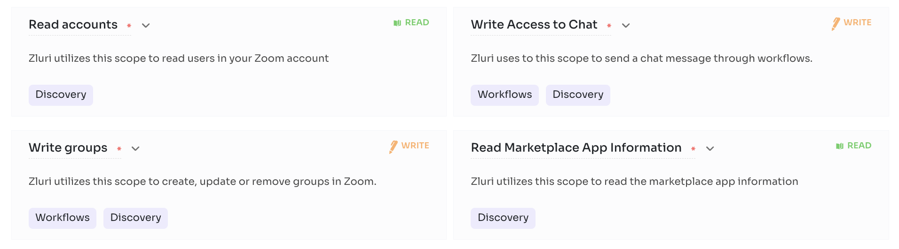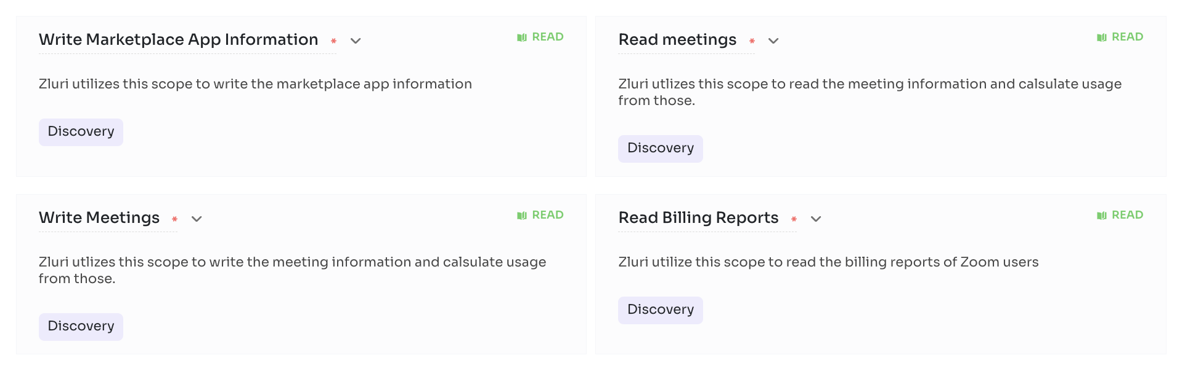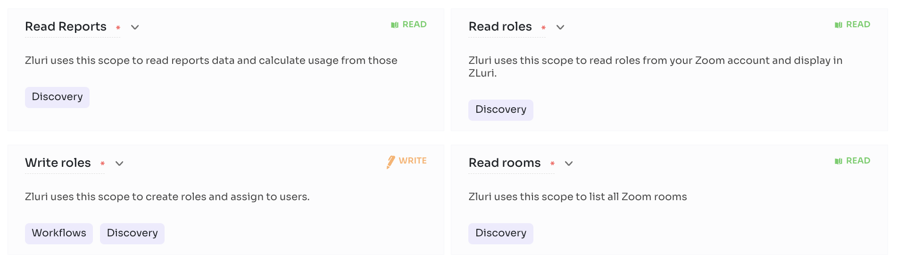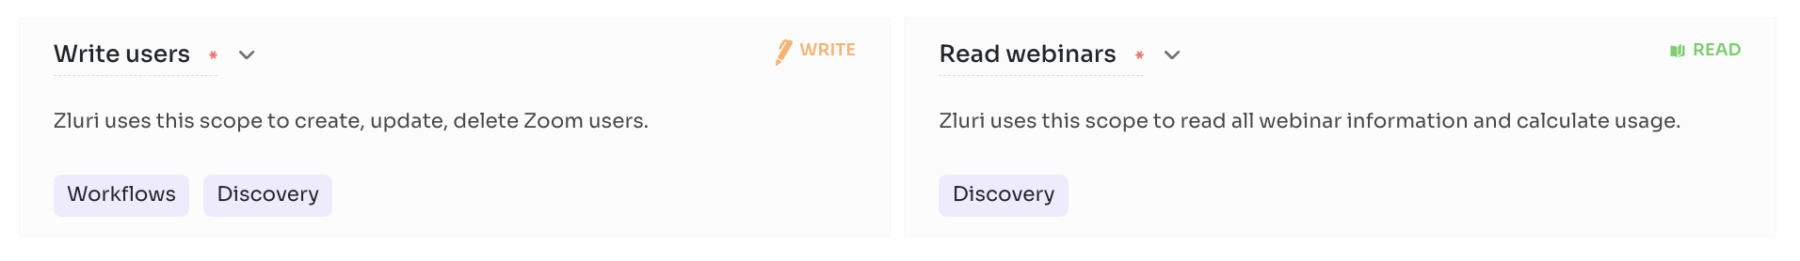
Steps to Connect
Step 1 :
Please visit the Help Article for the steps you need to perform before connecting Zoom to Zluri. Zluri's Zoom integration requires the Zoom owner to approve the app for installation from the marketplace. Without completing the step it shows an error as shown.

Step 2 :
Search Zoom's marketplace.
Click 'App Marketplace' under 'Advanced'

Step 3 :
Look for Zluri
Search for Zluri in the search bar.

Step 4 :
Approve Zluri on Zoom
Click approve use of this app

Step 5 :
Save the settings
You can select either all users or specific user of this account.

Step 6 :
Select Scopes for Zoom
Select scopes according to your needs to make the most out of Zluri's Discovery, Workflows, SAML or License Management features.

You can also select default scopes for a hassle-free experience.

Step 7 :Connect with Zoom by authorising and save instance
Integration with Zoom requires authorization from the Zoom administrator. If you have the Zoom credentials you can authorise yourself. Or you can send an invite to your co-worker to complete the authorization.

Once connected, Zluri allows you to save this connection instance. You can also connect multiple instances of an integration with additional scopes according to your requirements.

Adobe - VIP Plan

Unified design environment for publishing in print, on the web and on mobile devices.

Zluri + Adobe Creative Cloud
With direct integration with Adobe Creative Cloud, you can easily track which users use Adobe Creative Cloud & how frequently they use Adobe Creative Cloud and audit their access regularly to meet your security requirements. You can also monitor Adobe Creative Cloud usage & optimise spend. With onboarding & offboarding workflows you can automate the complex process of adding a user to Adobe Creative Cloud or removing a user from Adobe Creative Cloud .
Connect Adobe Creative Cloud to Zluri discover Adobe Creative Cloud users & usage
Integrating Adobe Creative Cloud with Zluri gives you detailed visibility into Adobe Creative Cloud users & usage. You can track which users hold Adobe Creative Cloud licences & how frequently they use Adobe Creative Cloud. You can also identify inactive users to optimise Adobe Creative Cloud licences & spend.

Manage Roles in Adobe Creative Cloud
You can automatically assign your employees to groups in Adobe Creative Cloud, which are created around attributes you design. Configure your groups using specific employee names, or by fields in Zluri such as department, role, employment status, or management level.

Create and Remove Accounts in Adobe Creative Cloud
Connect Adobe Creative Cloud with Zluri to automatically create and remove user accounts when you onboard and offboard employees. Automate adding users to all required channels through workflows.

Manage Groups in Adobe Creative Cloud
You can automatically assign your users to Groups in Adobe Creative Cloud account, which are created around attributes you design. Configure your groups using specific employee names, or by fields in Zluri such as department, role, employment status, or management level.

Get Supplier Information:
Access the supplier information for your organisations seamlessly through Zluri.

Supported Plans
- Business
- Schools & Universities

Integration Details
- User Source status
- Email
- Licence Info

Scopes
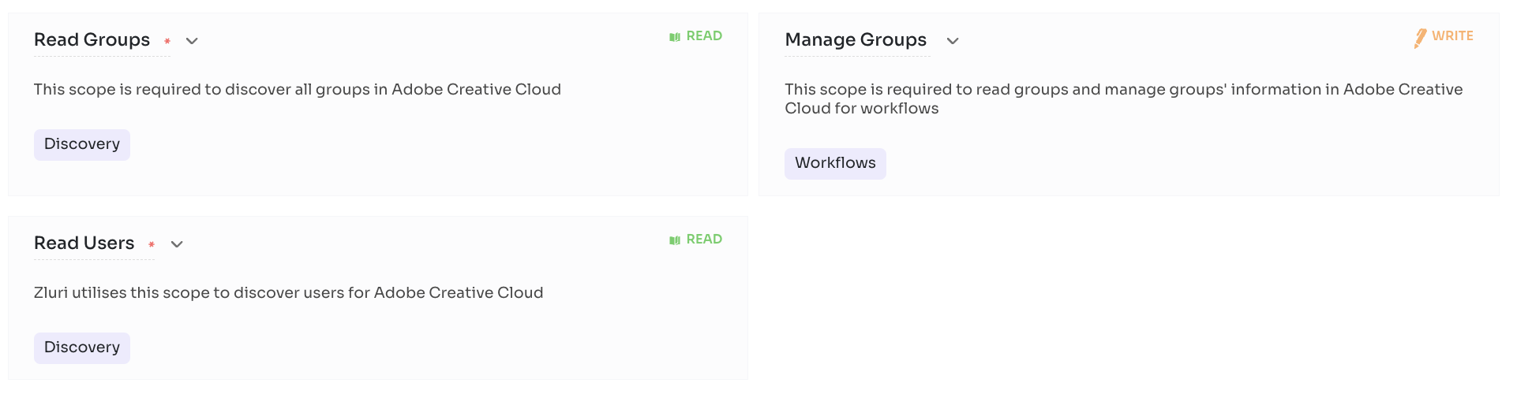

Steps to connect

Step 0 : Before you begin integration at Zluri
- Ensure to have the Adobe Creative Cloud Administrator account.
- Ensure to have the Adobe Creative Cloud API Credentials (Client ID, Client secret, Technical Account ID and Organization ID).
Step 1 : Get API credentials at Adobe Creative Cloud
- Login to Adobe developer Console i.e. https://console.adobe.io/
- Change your role to System Administrator of the organization
- Create a new Project by clicking the button 'Create New Project'
- In the project, select 'Add API'
- In the list select 'Adobe Services'
- Select User Management API and click on Next.
- Select the type of Authentication as 'Service Account (JWT)' and click 'Next'. Note: This authentication method will be supported until 2025
- Select the first option "Generate a Key pair" and click on 'Generate keypair'
- It will download a [config.zip]() file, which contains a file named private.key. Copy the file content and paste it in the private key field in zluri
- Save the configured API to your project by clicking the Save Configured API button in bottom right
- Copy the Client ID, Client secret, Technical Account ID and Organization ID and paste it in Zluri UI
Step 2 : Begin integration at Zluri

Step 3 :Review and add scopes
- Review the listed Required Scopes.
- Add additional Other Scopes (optional).
- Proceed further to initiate Self or Co-worker authorization.
Step 4 :Authorise connection request
Enter the following info
- Client ID, Client secret, Technical Account ID, and Organization ID

Google Workspace
Google Workspace, formerly known as G Suite, is a collection of cloud computing, productivity and collaboration tools, software and products developed and marketed by Google. It was first launched in 2006 as Google Apps for Your Domain and rebranded as G Suite in 2016.
Zluri + Google Workspace
Integrate Google Workspace with Zluri to discover all the apps your employees use, app usage and detailed security overview of each application. You can also add users to Google workspace and automate onboarding/offboarding processes. Zluri's integration with Google Workspace includes the following capabilities.

Integrate Google Workspace with Zluri to discover shadow IT
Enable Google Workspace data to flow into Zluri to discover shadow IT, and unlock powerful reporting and workflow automation. Use Google Workspace data to trigger custom workflows and alerts - no code required. Integrations automatically merges Google Workspace data to the Zluri employee record, so you can run new reports that combine any data within Zluri with Google Workspace data.

Get detailed security analysis of each application
Integrating Google workspace with Zluri gives you detailed security analysis of each application signed in through Google workspace. It highlights the applications having risk sensitive scope access and gives you an overall threat perception of your application ecosystem.

Onboard & offboard employees with a single click
You can realise the full potential of our workflows by seamlessly adding users to Google Workspace, removing users, assigning licences etc. just by integrating Zluri with Google workspace. Automate all such tasks with a single click.
Manage groups
You can assign your employees to groups in Google Workspace, which are created around attributes like project and team. Managing groups in Google Workspace takes your provisioning automation to the next level.

Supported Plans
- Business Starter
- Business Standard
- Business Plus
- Enterprise

Integration Details
- Department
- Designation
- Two-Factor authentication
- User Created Date
- Last Login
- Sign In Activity
- Activity Log
- User Source status
- Role
- Email
- Audit log
- Licence Info
- Integration log
- Group
Scopes
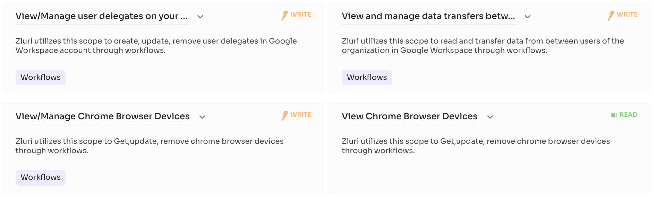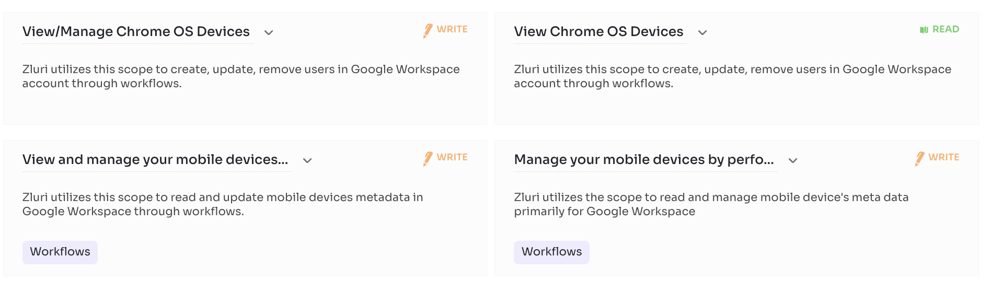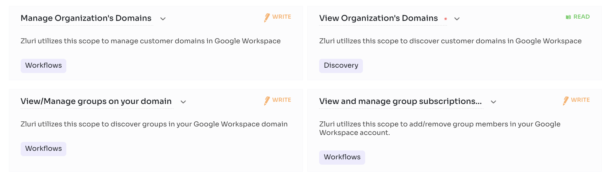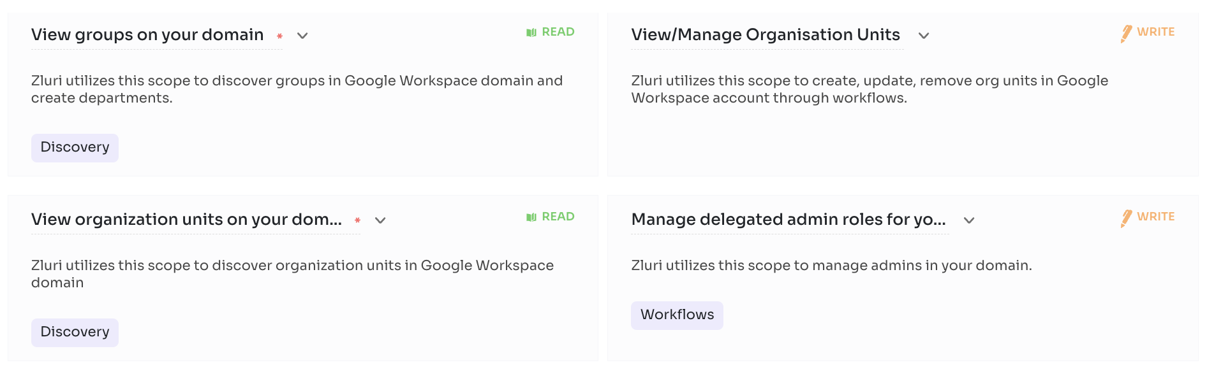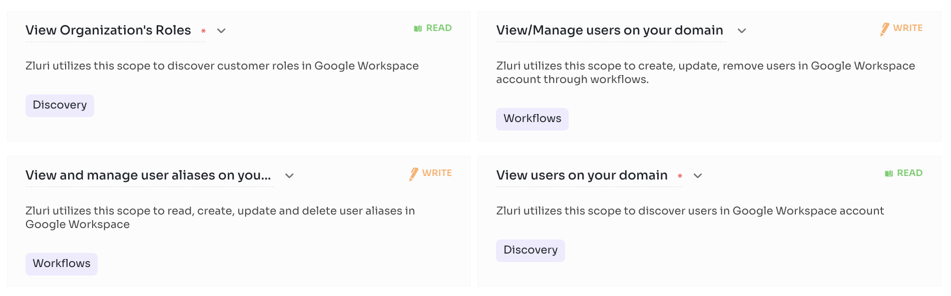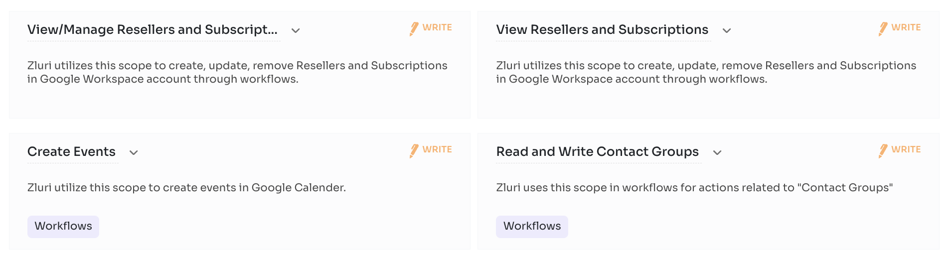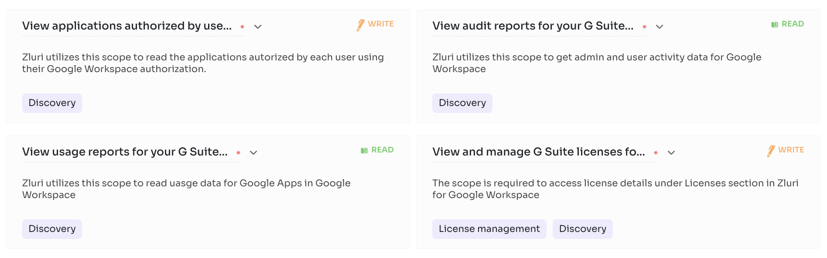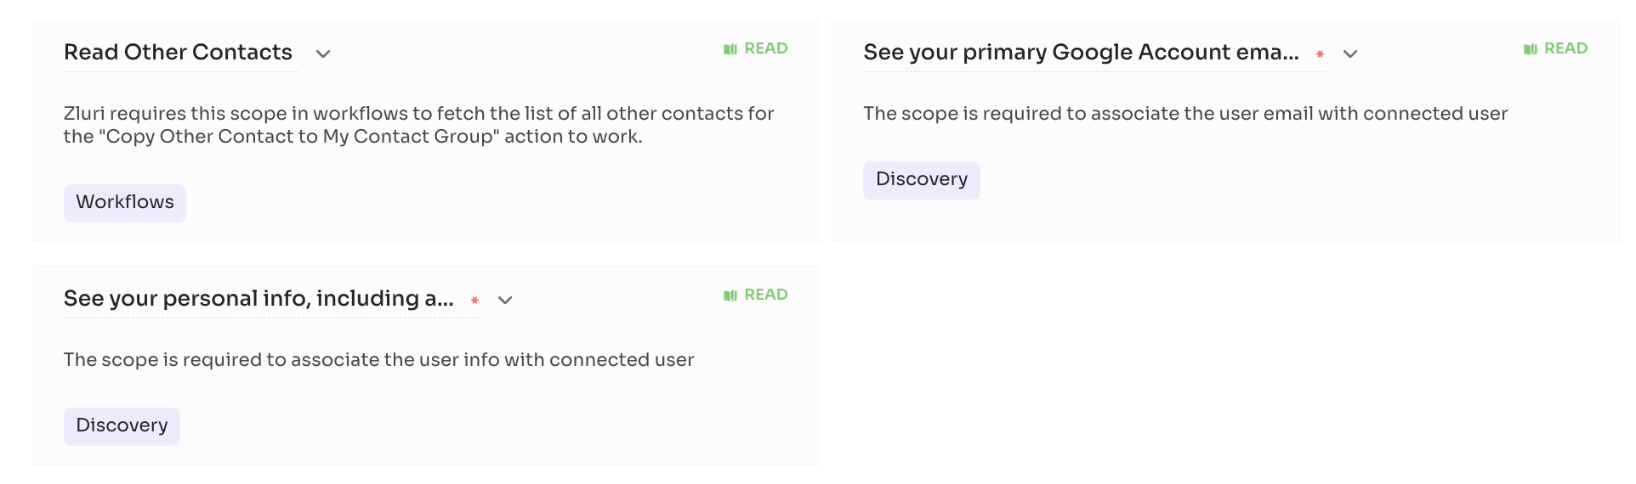

Steps to Connect
Step 1 :
To integrate Google Workspace with Zluri, you will need to have one specific role to connect the integration successfully. Although we prefer to connect using
Super Admin role.

Step 2 :Want to Create a Custom Role for Zluri?
You can create a custom role and connect zluri with google workspace by authenticating the custom account.

Step 3 :Select Scopes for Google Workspace
Select scopes according to your needs to make the most out of Zluri's Discovery, Workflows, SAML or License Management features.

You can also select default scopes for a hassle-free experience.

Step 4 :
Integration with Google Workspace requires authorization from the Google Workspace administrator. If you have the Google Workspace credentials you can authorize yourself. Or you can send an invite to your co-worker to complete the authorization.

Once connected, Zluri allows you to save this connection instance. You can also connect multiple instances of an integration with additional scopes according to your requirements.

Step 5 :

If there arises an issue stating admin_policy_enforced, it is because API Access is Restricted. Please follow the below steps to fix this and enable API Access:
Log in to the Google Workspace Admin Console. Go to Security > API Controls > Manage Google Services. Find Google Workspace Admin and select Change Access
Select Unrestricted: Any user-approved app can access a service to enable API Access

Microsoft Intune

Enables secure mobile productivity. Enterprise mobility. Identity-driven security across devices, platforms, apps, and data. Modern Windows & Mac management.

Zluri + Microsoft Intune
With direct integration with Microsoft Intune , you can easily track which users hold Microsoft Intune licences & how frequently they use Microsoft Intune . You can also monitor Microsoft Intune usage & optimise spend.
Connect Microsoft Intune to Zluri discover Microsoft Intune users & usage
Integrating Microsoft Intune with Zluri gives you detailed visibility intoMicrosoft Intune users & usage. You can track which users use Microsoft Intune & how frequently they use Microsoft Intune .

Supported Plans
- MS 365 for business
- Enterprise Mobility + Security E3
- Microsoft 365 Business Premium
- Microsoft 365 F1
- Microsoft 365 F3
- Microsoft 365 Business Premium

Integration Details
- Email

Scopes

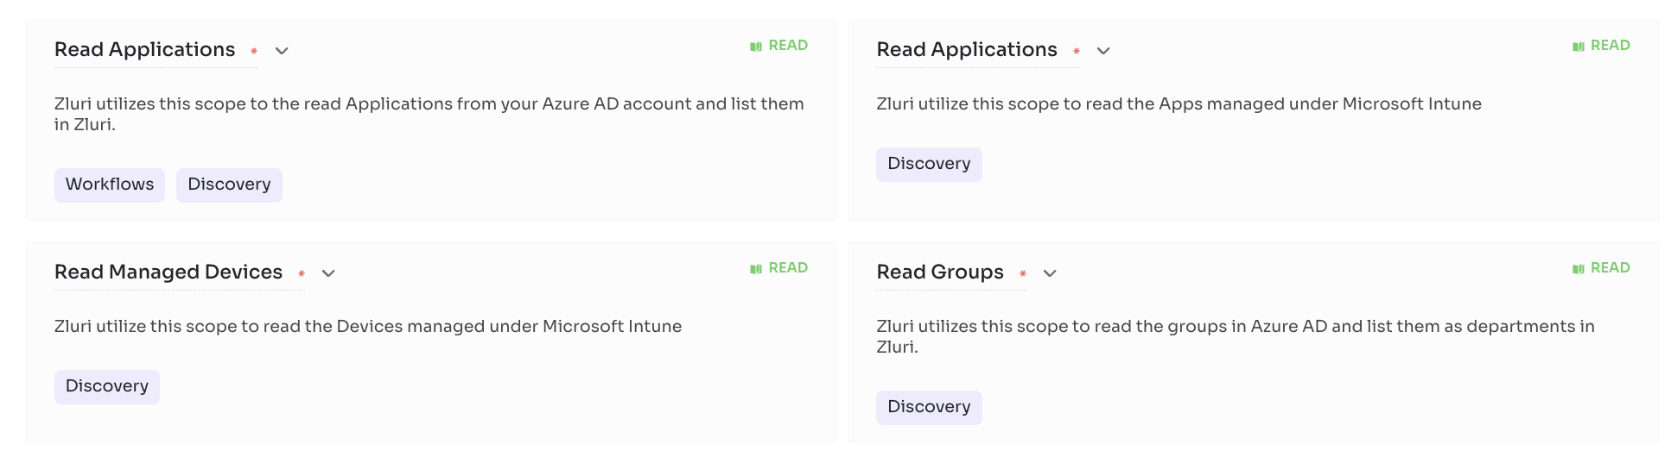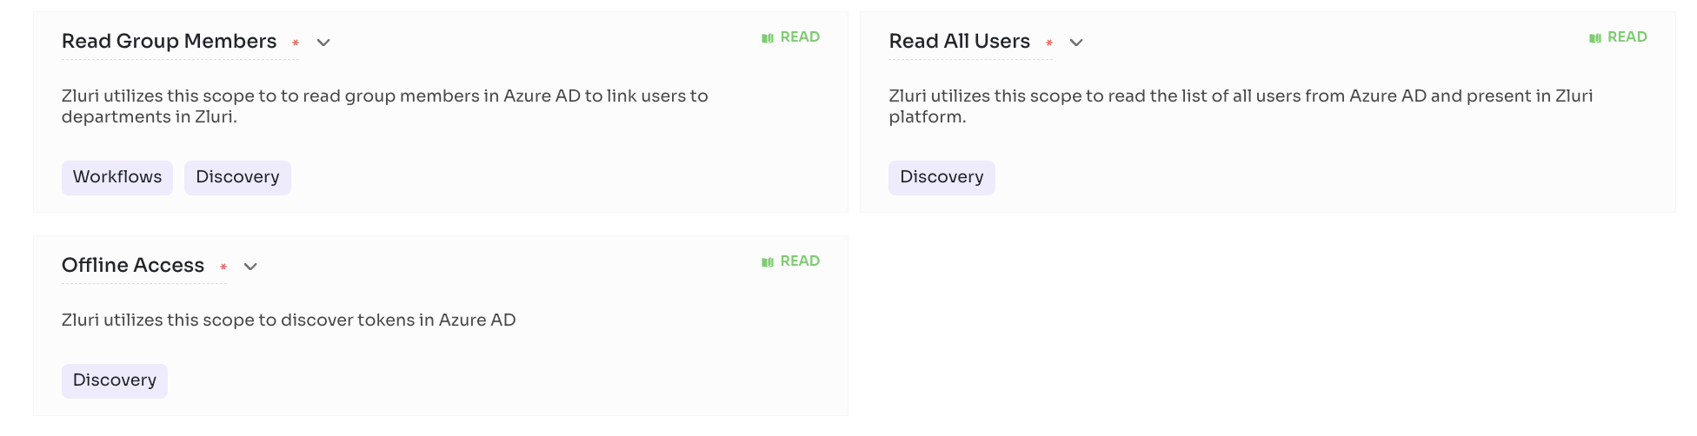

Steps to connect

Step 1 :
Select Scopes for Microsoft Intune. There are only default scopes available for Microsoft Intune, it will be selected by default.
Step 2 :
Integration with Microsoft Teams requires authorization from the Microsoft Intune administrator. If you have the Microsoft Intune Admin credentials you can authorize yourself. Or you can send an invite to your co-worker to complete the authorization.
Step 3 :
Once connected, Zluri allows you to save this connection instance. You can also connect multiple instances of an integration with additional scopes according to your requirements.

Jamf Pro

By concentrating on helping organisations succeed with Apple, Jamf provides an industry-leading device management solution for IT. With powerful management and customization options, Jamf Pro delivers everything IT needs to maximise their time and enable end users to be more creative, productive and happier.

Zluri + Jamf Pro
With direct integration with Jamf Pro, you can easily track which users use Jamf Pro & how frequently they use Jamf Pro and audit their access regularly to meet your security requirements. You can also monitor Jamf Pro usage & optimise spend. With onboarding & offboarding workflows you can automate the complex process of adding a user to Jamf Pro or removing a user from Jamf Pro.
Connect Jamf Pro to Zluri discover Jamf Pro users & usage
Integrating Jamf Pro with Zluri gives you detailed visibility into Jamf Pro users & usage. You can track which users hold Jamf Pro licences & how frequently they use Jamf Pro. You can also identify inactive users to optimise Jamf Pro licences & spend.

Create and Remove Accounts in Jamf Pro
Connect Jamf Pro with Zluri to automatically create and remove user accounts when you onboard and offboard employees. Automate adding users to all required channels through workflows.

Manage Groups in Jamf Pro
You can automatically assign your users to Groups in the Jamf Pro account, which are created around attributes you design. Configure your groups using specific employee names, or by fields in Zluri such as department, role, employment status, or management level.

Get Supplier Information:
Access the supplier information for your organisations seamlessly through Zluri.

Supported Plans
- Subscription Based

Integration Details
- Activity Log
- Email
- Device Info

Scopes
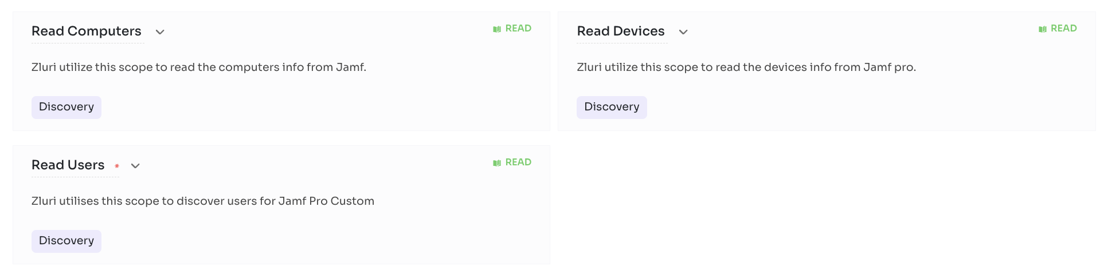

Steps to Connect

Step 1 : Please enter your username, password you use to login to your Jamf portal.
Step 2 : Please enter your organisation name in the 'organisation' field i.e. If your Jamf portal URL is https://zluri.jamfcloud.com, Your organisation name is 'zluri'
Step 3 :
If you have SSO Enabled you have to fill the username and password form fields using ClientId and Client Secret which you can create by following Step 4 and Step 5 below
Step 4 :
Click on Settings -> API Roles and Clients -> API Roles -> New -> Fill the Name -> Select Read User Extension Attributes, Read Static User Groups, Read Smart User Groups, Read User, View JSS Information, Read Mobile devices, Read Computers, Read Advanced Computer Searches in Privileges -> Save.
Step 5 :
Click on Settings -> API Roles and Clients -> API Clients -> New -> Fill the Name -> Select the Role we created in Step 4 in the API Roles -> Enable API Client -> Save -> Generate Client Secret -> Copy the Client Id and Client Secret from there and paste it here.

Slack

Slack is a communications and workflow solution designed for teams. Using Slack, you can set up channels, which can be around any theme, project, client or department. You can invite people to join these channels, or make them private, and people can leave whenever they want. With Slack’s search functionality, you can quickly skip to past communications. You can also start conversations to add them to your favourites, and allow you to quickly access them again in the future. Slack threads allow people to carry on the conversation in a separate place, rather than cluttering up the channel with their responses. With Slack, you can share PDFs, images, videos, and gifs, and you can mention one individual or multiple people within channels to get their attention. You can also directly message people when you want to have 1-2-1 conversations, and quickly add more people to that conversation if you need more opinions.

Zluri + Slack

With direct integration with Slack, you can easily track which users hold Slack licences & how frequently they use Slack. You can also monitor Slack usage & optimise spend. With onboarding & offboarding workflows you can automate the complex process of adding a user to Slack or removing a user from Slack.

Connect Slack to Zluri discover Slack users & usage

Integrating Slack with Zluri gives you detailed visibility into Slack users & usage. You can track which users hold Slack licences & how frequently they use Slack. You can also identify inactive users to optimise Slack licences & spend..

Add and Remove Users in Slack workspace

Connect Slack with Zluri to automatically create and remove user accounts when you onboard and offboard employees. Automate adding users to all required channels through workflows.

Manage Groups & Channels in Slack

You can automatically assign your employees to groups and channels in Slack, which are created around attributes you design.

Keep track of Slack licences

Keep track of licences being used by your employees in your slack workspace.

Supported Plans

Pro

Business

Enterprise Grid

Integration Details

User Profile Image

Activity Log

User Source status

Role

Email

License Info

Integration log

Group

Scopes

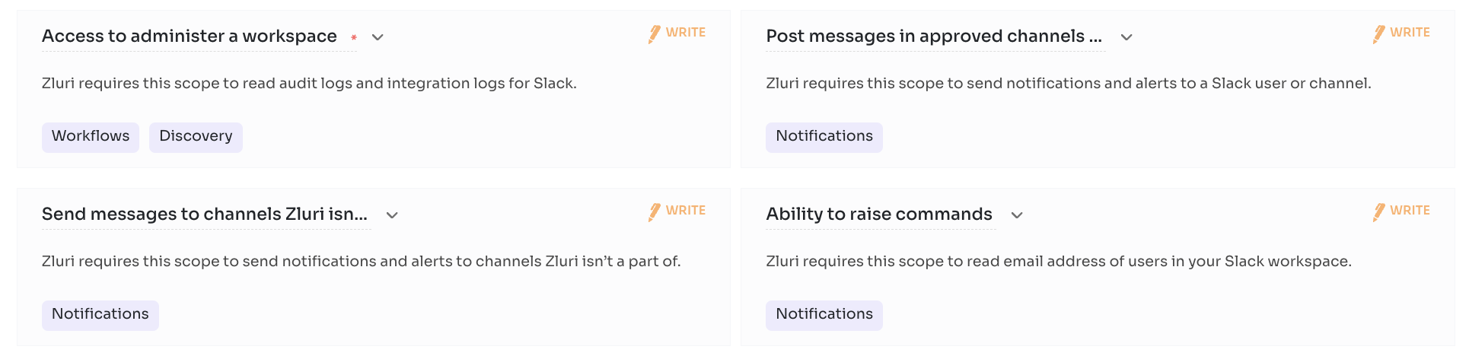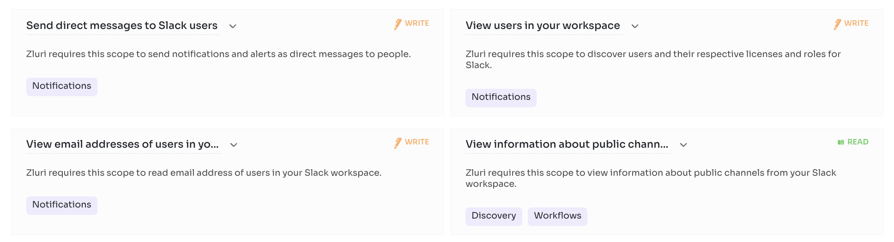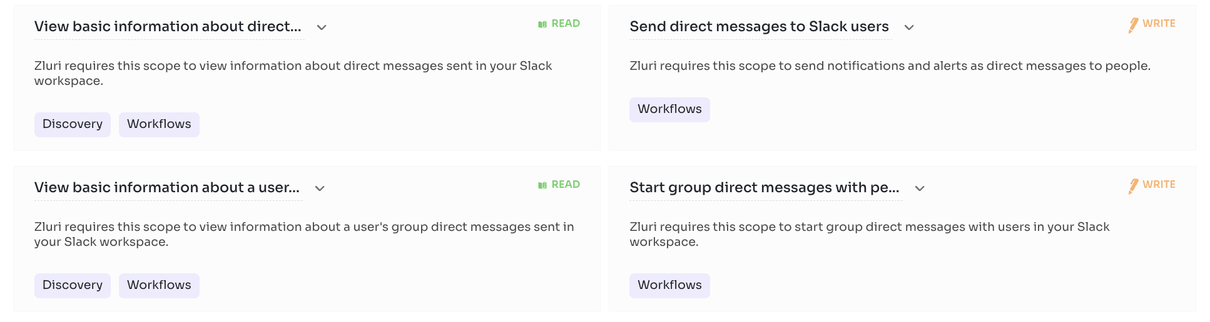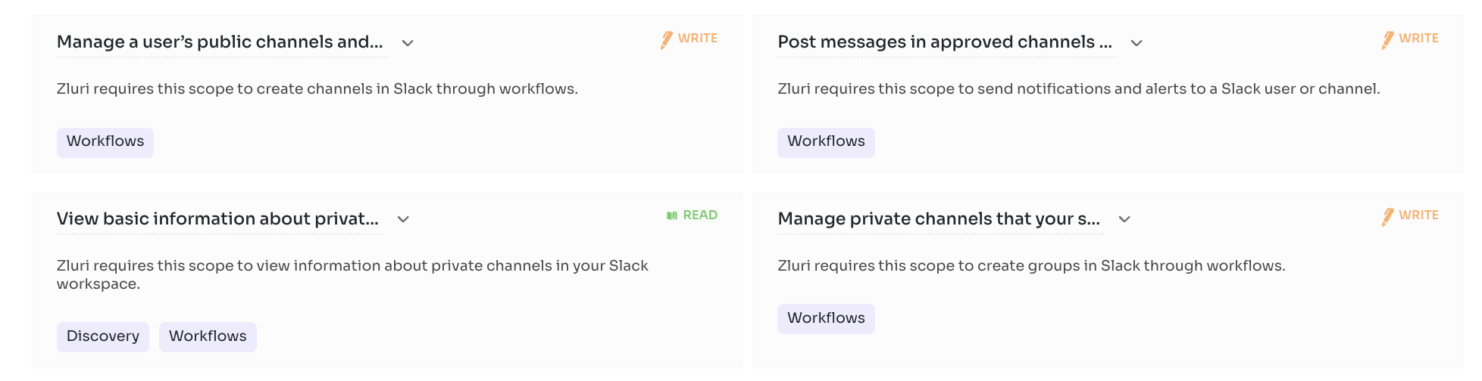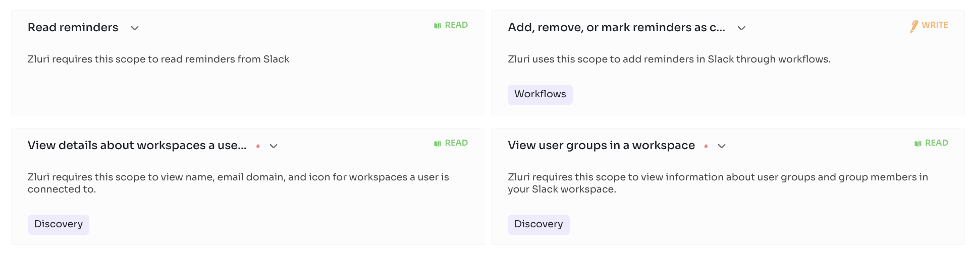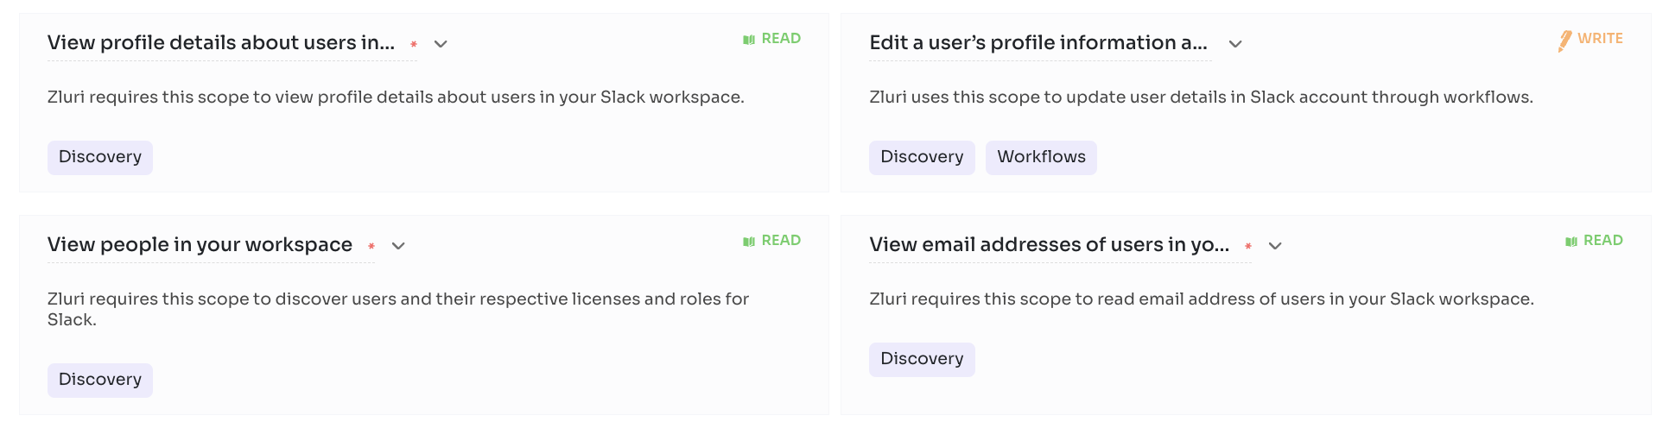

Steps to connect

Step 0 : Before you begin integration at Zluri

Ensure to have the Slack user account.

Step 1 :Log in to your Slack account with your credentials.

Step 2 :Begin integration at Zluri

Step 3 :Review and add scopes Review the listed Required Scopes. Add additional Other Scopes (optional).

Step 4 :Authorise connection request

